DBMS ASSIGNMENT – 6

***Roll Number: U19CS012***

***Name: BHAGYA VINOD RANA***

1.) Create the Following Table

A.) Employee

|  |  |
| --- | --- |
| Attribute | Information |
| Empno | Identifies the Employee’s |
| Emp_name | Employee name & Cannot be blank |
| Emp_Join_Date | Date of Join of employee & Default is the system date |
| Emp_Status | Employee status & Can be either P, C or R |

B.) Project

|  |  |
| --- | --- |
| Attribute | Information |
| Project_Code | Identifies the projects |
| Project_Description | Name of the project. Cannot be blank and have to be unique |
| Project_Start_Date | Start date of the project. Cannot be blank |
| Project_End_Date | End date of the project |

C.) Project Allocation

|  |  |
| --- | --- |
| Attribute | Information |
| Project Code | Project Code |
| Empno | Employee number |
| Emp_Proj_Alloc_Date | Employee project allocation date |
| Emp_Proj_Release_Date | Employee project release date |

Insert the Given Data into the Database.

**Initial Table:**

**EMPLOYEE TABLE**

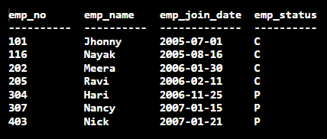

**PROJECT TABLE**

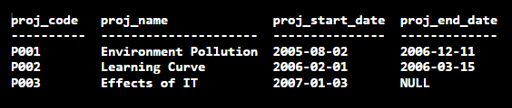

**PROJECT_ALLOCATION TABLE**

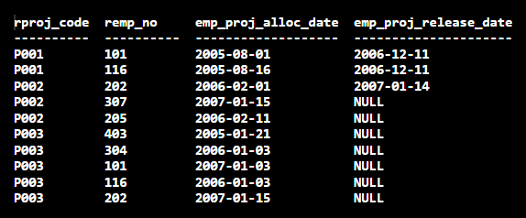

**SQL-Code [**SQLite 3.29.0**]:**

BEGIN TRANSACTION;

CREATE TABLE EMPLOYEE(

    emp_no INTEGER PRIMARY KEY,

    emp_name TEXT NOT NULL,

*-- YEAR MONTH DAY [Important Mistake]*

    emp_join_date DATE DEFAULT CURRENT_DATE,

    emp_status VARCHAR(1)

*-- No Semicolon at End of Last Attribute*

);

CREATE TABLE PROJECT(

    proj_code TEXT PRIMARY KEY,

    proj_name TEXT NOT NULL UNIQUE,

*-- YEAR MONTH DAY [Important Mistake]*

    proj_start_date DATE NOT NULL,

    proj_end_date DATE

*-- No Semicolon at End of Last Attribute*

);

CREATE TABLE PROJ_ALLOC(

    rproj_code TEXT,

    remp_no  INTEGER,

*-- YEAR MONTH DAY [Important Mistake]*

    emp_proj_alloc_date DATE,

    emp_proj_release_date DATE

*-- No Semicolon at End of Last Attribute*

);

INSERT INTO EMPLOYEE VALUES(101, 'Jhonny', '2005-07-01', 'C');

INSERT INTO EMPLOYEE VALUES(116, 'Nayak', '2005-08-16', 'C');

INSERT INTO EMPLOYEE VALUES(202, 'Meera', '2006-01-30', 'C');

INSERT INTO EMPLOYEE VALUES(205, 'Ravi', '2006-02-11', 'C');

INSERT INTO EMPLOYEE VALUES(304, 'Hari', '2006-11-25', 'P');

INSERT INTO EMPLOYEE VALUES(307, 'Nancy', '2007-01-15', 'P');

INSERT INTO EMPLOYEE VALUES(403, 'Nick', '2007-01-21', 'P');

INSERT INTO PROJECT VALUES('P001', 'Environment Pollution', '2005-08-02', '2006-12-11');

INSERT INTO PROJECT VALUES('P002', 'Learning Curve', '2006-02-01', '2006-03-15');

INSERT INTO PROJECT VALUES('P003', 'Effects of IT', '2007-01-03', NULL);

INSERT INTO PROJ_ALLOC VALUES('P001', 101, '2005-08-01', '2006-12-11');

INSERT INTO PROJ_ALLOC VALUES('P001', 116, '2005-08-16', '2006-12-11');

INSERT INTO PROJ_ALLOC VALUES('P002', 202, '2006-02-01', '2007-01-14');

INSERT INTO PROJ_ALLOC VALUES('P002', 307, '2007-01-15', NULL);

INSERT INTO PROJ_ALLOC VALUES('P002', 205, '2006-02-11', NULL);

INSERT INTO PROJ_ALLOC VALUES('P003', 403, '2005-01-21', NULL);

INSERT INTO PROJ_ALLOC VALUES('P003', 304, '2006-01-03', NULL);

INSERT INTO PROJ_ALLOC VALUES('P003', 101, '2007-01-03', NULL);

INSERT INTO PROJ_ALLOC VALUES('P003', 116, '2006-01-03', NULL);

INSERT INTO PROJ_ALLOC VALUES('P003', 202, '2007-01-15', NULL);

*-- Saving the Work*

COMMIT;

*-------------------------------------------------------------------*

*-- For Output Formatting [Human Understandable Form] in SQLite*

.mode column

.headers on

.separator ROW "\n"

.nullvalue NULL

*-------------------------------------------------------------------*

*-- SELECT * FROM EMPLOYEE;*

*-- SELECT * FROM PROJECT;*

*-- SELECT * FROM PROJ_ALLOC;*

*-- 1. List all the project names along with the employee names to whom the project is assigned.*

SELECT DISTINCT P.proj_name AS PROJECT_NAME,E.emp_name AS EMPLOYEE_NAME

FROM EMPLOYEE E, PROJECT P, PROJ_ALLOC R

WHERE (E.emp_no = R.remp_no) AND (P.proj_code = R.rproj_code)

ORDER BY P.proj_code;

*-- 2. Display the name of employees whose status is confirmed.*

SELECT emp_name AS EMPLOYEE_NAME

FROM EMPLOYEE

WHERE emp_status='C';

*-- For Checking*

SELECT emp_name AS EMPLOYEE_NAME,emp_status AS EMPLOYEE_STATUS

FROM EMPLOYEE

WHERE emp_status='C';

*-- 3. List the employees who have joined in the month of November.*

SELECT *

FROM EMPLOYEE

WHERE strftime('%m',emp_join_date) = '11';

*-- 4. List the projects which have started after 1st Jan 2006.*

SELECT *

FROM PROJECT

WHERE proj_start_date>'2006-01-01';

*-- 5. List all the employees who are working for the project entitled ‘Effects of IT’.*

SELECT E.emp_no AS EMPLOYEE_NO, E.emp_name AS EMPLOYEE_NAME

FROM EMPLOYEE E, PROJECT P,PROJ_ALLOC R

WHERE (P.proj_name = 'Effects of IT') AND (P.proj_code = R.rproj_code) AND (R.remp_no = E.emp_no);

*-- 6. List all the projects that are not yet completed.*

SELECT *

FROM PROJECT

WHERE proj_end_date IS NULL;

*-- 7. Display the Employees who are released from project having code P002.*

SELECT E.emp_no AS EMPLOYEE_NO, E.emp_name AS EMPLOYEE_NAME

FROM EMPLOYEE E, PROJECT P, PROJ_ALLOC R

WHERE (P.proj_code = 'P002') AND (R.emp_proj_release_date IS NOT NULL) AND (P.proj_code = R.rproj_code) AND (R.remp_no = E.emp_no);

*-- 8. Count and display the number of days it took for the completion of project P002.*

SELECT (julianday(proj_end_date)-julianday(proj_start_date)) AS DAYS_TAKEN_P002

FROM PROJECT

WHERE proj_code='P002';

*-- 9. List the name of employees along with the number of days they have worked for projects allocated to them.*

SELECT E.emp_no,E.emp_name,P.proj_name,(CASE

    WHEN  R.emp_proj_release_date IS NOT NULL

        THEN (julianday(R.emp_proj_release_date)-julianday(R.emp_proj_alloc_date))

*-- Any Reference Date can be Chosen, Here 1st Jan, 2009*

    ELSE (julianday('2009-01-01')-julianday(R.emp_proj_alloc_date))

        END) AS DAYS_TAKEN

FROM EMPLOYEE E, PROJECT P, PROJ_ALLOC R

WHERE (P.proj_code = R.rproj_code) AND (R.remp_no = E.emp_no);

*-- 10. Add a column Manager_id in the Projects table.*

*-- <NOT TO BE COMMENTED>*

ALTER TABLE PROJECT ADD manager_id;

*-- SELECT * FROM PROJECT;*

*-- 11. Update the Projects table with the following data:*

*-- Don't Forget to Uncomment the Query 10 to add manager_id to Table [Online Editor]*

*-- <NOT TO BE COMMENTED>*

UPDATE PROJECT SET manager_id = 101 WHERE proj_code = 'P001';

UPDATE PROJECT SET manager_id = 202 WHERE proj_code = 'P002';

UPDATE PROJECT SET manager_id = 116 WHERE proj_code = 'P003';

*-- SELECT * FROM PROJECT;*

*-- 12. A new project entitled “Election Rage” which will be starting on 1st March 2007 has been received.*

*--  Add these details in Projects table.*

*-- <NOT TO BE COMMENTED>*

INSERT INTO PROJECT (proj_code, proj_name, proj_start_date) VALUES('P004','Election Rage','2007-03-01');

*-- SELECT * FROM PROJECT;*

*-- 13. Project named “Effects of IT” is cancelled. Remove its details from the Projects table.*

*-- DELETE FROM PROJECT WHERE proj_name='Effects of IT';*

*-- SELECT * FROM PROJECT;*

*-- 14. List the projects with a time duration of more than 13 months [1yr + 1 month = 365 + 30 days = 395 days].*

SELECT P.proj_code, P.proj_name, Q.DAYS_TAKEN/30 AS 'AVERAGE MONTHS'

FROM PROJECT AS P, (

    SELECT P1.proj_code,( CASE

    WHEN P1.proj_end_date IS NOT NULL

        THEN (julianday(P1.proj_end_date)-julianday(P1.proj_start_date))

    ELSE

        (julianday('2009-01-01')-julianday(P1.proj_start_date))

    END) AS DAYS_TAKEN

    FROM PROJECT AS P1

) AS Q

WHERE (DAYS_TAKEN>(394)) AND (Q.proj_code = P.proj_code);

*-- 15. List the number of employees, project wise who have worked on the project in Feb – 2007.*

SELECT P.proj_code, P.proj_name, COUNT(FEB_WORK.remp_no) AS NUMBER_OF_EMPLOYEES

FROM (

    SELECT remp_no, rproj_code

    FROM PROJ_ALLOC

    WHERE (emp_proj_alloc_date <= '2007-02-01') AND ((emp_proj_release_date IS NULL) OR (emp_proj_release_date>='2007-02-28'))

) AS FEB_WORK, PROJECT AS P

WHERE (FEB_WORK.rproj_code = P.proj_code) GROUP BY FEB_WORK.rproj_code;

**Q. Write queries for the following:**

1. List all the project names along with the employee names to whom the project is assigned.

**Query:**

SELECT DISTINCT P.proj_name AS PROJECT_NAME,E.emp_name AS EMPLOYEE_NAME

FROM EMPLOYEE E, PROJECT P, PROJ_ALLOC R

WHERE (E.emp_no = R.remp_no) AND (P.proj_code = R.rproj_code)

ORDER BY P.proj_code;

**Output:**

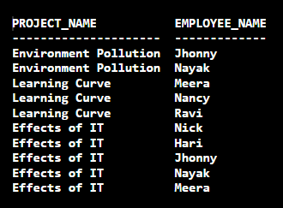

2. Display the name of employees whose status is confirmed.

**Query:**

SELECT emp_name AS EMPLOYEE_NAME

FROM EMPLOYEE

WHERE emp_status='C';

**For Checking:**

SELECT emp_name AS EMPLOYEE_NAME,emp_status AS EMPLOYEE_STATUS

FROM EMPLOYEE

WHERE emp_status='C';

**Output:**

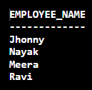 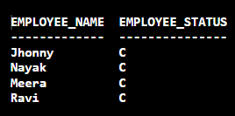

3. List the employees who have joined in the month of November.

**Query:**

SELECT *

FROM EMPLOYEE

WHERE strftime('%m',emp_join_date) = '11';

**Output:**

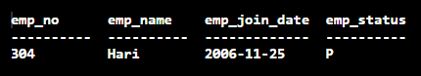

4. List the projects which have started after 1st Jan 2006.

**Query:**

SELECT *

FROM PROJECT

WHERE proj_start_date>'2006-01-01';

**Output:**

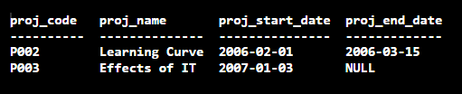

5. List all the employees who are working for the project entitled ‘Effects of IT’.

**Query:**

SELECT E.emp_no AS EMPLOYEE_NO, E.emp_name AS EMPLOYEE_NAME

FROM EMPLOYEE E, PROJECT P,PROJ_ALLOC R

WHERE (P.proj_name = 'Effects of IT') AND (P.proj_code = R.rproj_code) AND (R.remp_no = E.emp_no);

**Output:**

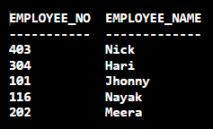

6. List all the projects that are not yet completed.

**Query:**

SELECT * FROM PROJECT WHERE proj_end_date IS NULL;

**Output:**

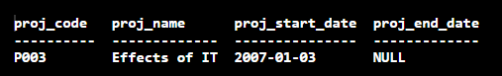

7. Display the Employees who are released from project having code P002.

**Query:**

SELECT E.emp_no AS EMPLOYEE_NO, E.emp_name AS EMPLOYEE_NAME

FROM EMPLOYEE E, PROJECT P, PROJ_ALLOC R

WHERE (P.proj_code = 'P002') AND (R.emp_proj_release_date IS NOT NULL) AND (P.proj_code = R.rproj_code) AND (R.remp_no = E.emp_no);

**Output:**

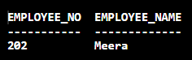

8. Count and display the number of days it took for the completion of project P002.

**Query:**

SELECT (julianday(proj_end_date)-julianday(proj_start_date)) AS DAYS_TAKEN_P002

FROM PROJECT

WHERE proj_code='P002';

**Output:**

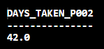

9. List the name of employees along with the number of days they have worked for projects allocated to them.

**Query:**

SELECT E.emp_no,E.emp_name,P.proj_name,(CASE

    WHEN  R.emp_proj_release_date IS NOT NULL

        THEN (julianday(R.emp_proj_release_date)-julianday(R.emp_proj_alloc_date))

*-- Any Reference Date can be Chosen, Here 1st Jan, 2009*

    ELSE (julianday('2009-01-01')-julianday(R.emp_proj_alloc_date))

        END) AS DAYS_TAKEN

FROM EMPLOYEE E, PROJECT P, PROJ_ALLOC R

WHERE (P.proj_code = R.rproj_code) AND (R.remp_no = E.emp_no);

**Output:**

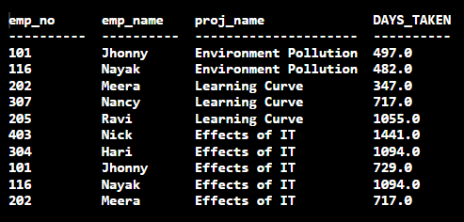

10. Add a column Manager_id in the Projects table.

**Query:**

ALTER TABLE PROJECT ADD manager_id;

SELECT * FROM PROJECT;

**Output:**

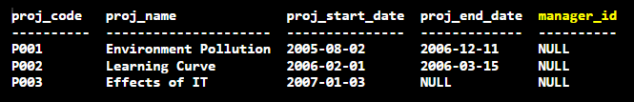

11. Update the Projects table with the following data:

|  |  |
| --- | --- |
| Project_Code | Manager_ID |
| P001 | 101 |
| P002 | 202 |
| P003 | 116 |

**Query:**

UPDATE PROJECT SET manager_id = 101 WHERE proj_code = 'P001';

UPDATE PROJECT SET manager_id = 202 WHERE proj_code = 'P002';

UPDATE PROJECT SET manager_id = 116 WHERE proj_code = 'P003';

SELECT * FROM PROJECT;

**Output:**

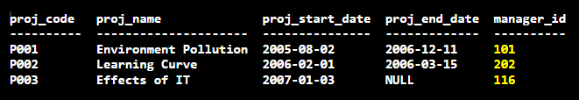

12. A new project entitled “Election Rage” which will be starting on 1st March 2007 has been received. Add these details in Projects table.

**Query:**

INSERT INTO PROJECT (proj_code, proj_name, proj_start_date) VALUES('P004','Election Rage','2007-03-01');

SELECT * FROM PROJECT;

**Output:**

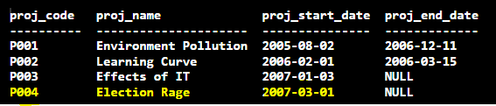

13. Project named “Effects of IT” is cancelled. Remove its details from the Projects table.

**Query:**

DELETE FROM PROJECT WHERE proj_name='Effects of IT';

SELECT * FROM PROJECT;

**Output:**

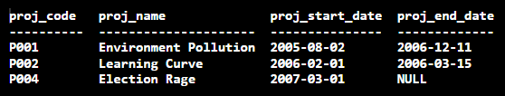

14. List the projects with a time duration of more than 13 months.

**Query:**

SELECT P.proj_code, P.proj_name, Q.DAYS_TAKEN/30 AS 'AVERAGE MONTHS'

FROM PROJECT AS P, (

    SELECT P1.proj_code,( CASE

    WHEN P1.proj_end_date IS NOT NULL

        THEN (julianday(P1.proj_end_date)-julianday(P1.proj_start_date))

    ELSE

        (julianday('2009-01-01')-julianday(P1.proj_start_date))

    END) AS DAYS_TAKEN

    FROM PROJECT AS P1

) AS Q

WHERE (DAYS_TAKEN>(394)) AND (Q.proj_code = P.proj_code);

**Output:**

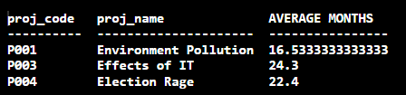

15. List the number of employees, project wise who have worked on the project in Feb – 2007. [Question 13 Query Commented]

**Query:**

SELECT P.proj_code, P.proj_name, COUNT(FEB_WORK.remp_no) AS NUMBER_OF_EMPLOYEES

FROM (

    SELECT remp_no, rproj_code

    FROM PROJ_ALLOC

    WHERE (emp_proj_alloc_date <= '2007-02-01') AND ((emp_proj_release_date IS NULL) OR (emp_proj_release_date>='2007-02-28'))

) AS FEB_WORK, PROJECT AS P

WHERE (FEB_WORK.rproj_code = P.proj_code) GROUP BY FEB_WORK.rproj_code;

**Output:**

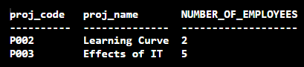

**Submitted By:**

**BHAGYA VINOD RANA**

**U19CS012**